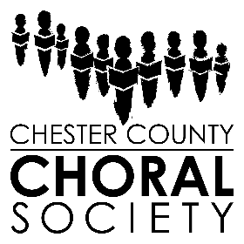
Concert Program Advertisement Order Form
Concert Season 2021-2022

Name of Business ___________________________________________________________
Contact Name ______________________________________________________________
Address ____________________________________________________________________
Telephone __________________________________________________________________
Email ______________________________________________________________________

____ $1,000 Inside front cover full page ad (5 x 8 in.)
____ $750 Inside back cover full page ad (5 x 8 in.)
____ $500 Full page ad (5 x 8 in.)
____ $250 Half page ad (5 x 3.875 in.)
____ $125 Quarter page ad (vertical: 2.375 x 3.875 in.; horizontal 5 x 1.875 in.)

All Ads will be on white paper printed in black ink. Ad location is not guaranteed and CCCS is not responsible for typographical errors in your Ad copy. Please return this form, payment, and ad copy. Camera-ready copy must be sent electronically in pdf, tif, or jpeg format, and within size limits of the Ad you are purchasing. Files must be saved at 300 pixels per inch and in greyscale for offset printing.

Deadline for Ad submission to CCCS is April 12, 2022.

Please send electronic ad copy and this form to:
Jaymie Lacombe, VP Administration, jaymie.lacombe@gmail.com

Make checks payable to “CCCS” and mail payments to:
Chester County Choral Society, Attn. Program Ads, P.O. Box 3466, West Chester, PA 19381

